Note to teacher: Weeks not included in the document should were mainly or fully done in python, please view the respective files for my answers.

Week 2
Activity 2
Some things I found:
- You can use any datatype
- No fields are mandatory, you can leave some important stuff empty
- Some fields should give you a choice instead of a open text box, take gender for example
Activity 3
- Change Male to M or Female to F otherwise null
- Dutch students should be changed to dutch (not the Netherlands, Netherlands, dutch)
- Your way of coming to school should be changed to a one word answer, like foot, car or bicycle.
- Both trousers questions should be numeric only
- Change k to 000, for the right number, removing letters and symbols is also requried
Activity 4

MCAR; The questions did not tell a story, meaning there is no relation between the given data.

Week 4

Part 1:
- Adding files to HDFS: “hadoop fs –put (insert filename here)”

Part 2:
- Creating movie table: “create table movies (id int, title string, release_date string, video_release_date string, imdb_url string, genre_unknown int, genre_action int, genre_adventure int, genre_animation int, genre_childrens int, genre_comedy int, genre_crime int, genre_documentary int, genre_drama int, genre_fantasy int, genre_film_noir int, genre_horror int, genre_musical int, genre_mystery int, genre_romance int, genre_sci_fi int, genre_thriller int, genre_war int, genre_western int) ROW FORMAT DELIMITED FIELDS TERMINATED BY '|' STORED AS TEXTFILE;”

Part 3:
- Number of males and females: “select gender, count(*) from users group by gender;”
Result: F 273
M 670
- Occupations per Gender: “select occupation, gender, count(*) from users group by gender, occupation;”
Resulting in 41 occupations whit man dominating most jobs
- Get the name of the highest rated movie for both male and females:
“SELECT users.gender, movies.title, avg(ratings.rating) as avg_rating FROM movies JOIN ratings ON (movies.id = ratings.item_id) JOIN users ON (ratings.user_id = users.id) WHERE users.occupation = 'student' GROUP BY users.gender, movies.title ORDER BY avg_rating desc LIMIT 1;”
result: M Before the Rain (Pred dozhdot) (1994) 5.0
F Sliver (1993) 5.0

Part 4:
I would use AVG which stands for average, depending on the amount of ratings each movie has will give a rather accurate rating.

Part 5:
It uses a “weighted average” this causes some votes to have a better affect.

Week 5
Part 1: (good luck with reading that)
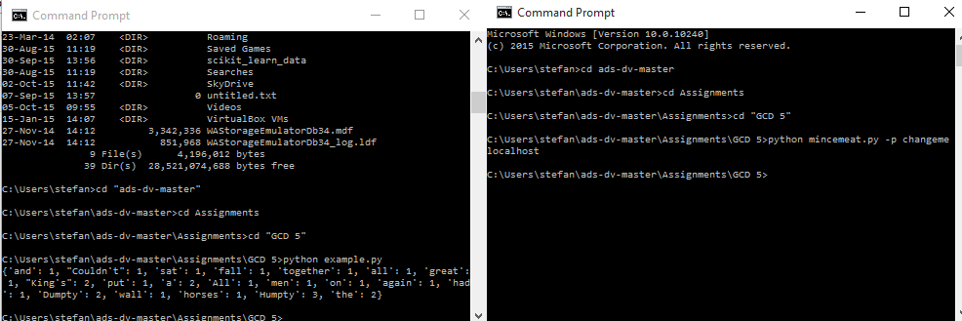
Part 2:
2.1:
Code:
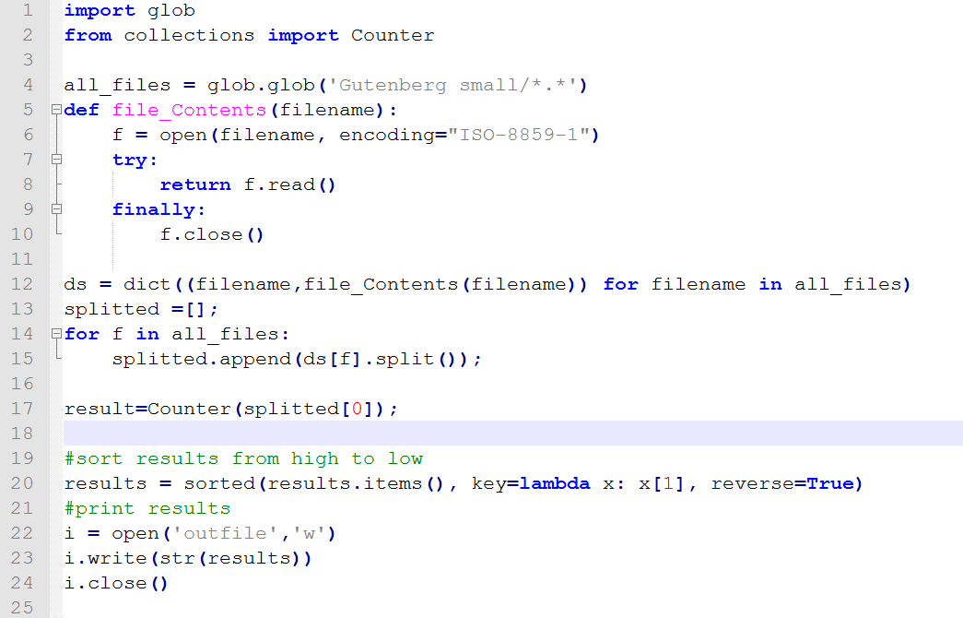
Results:
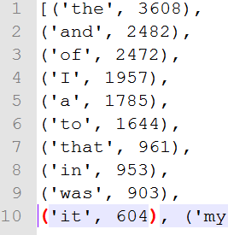
2.2:

Week 6
Prep:
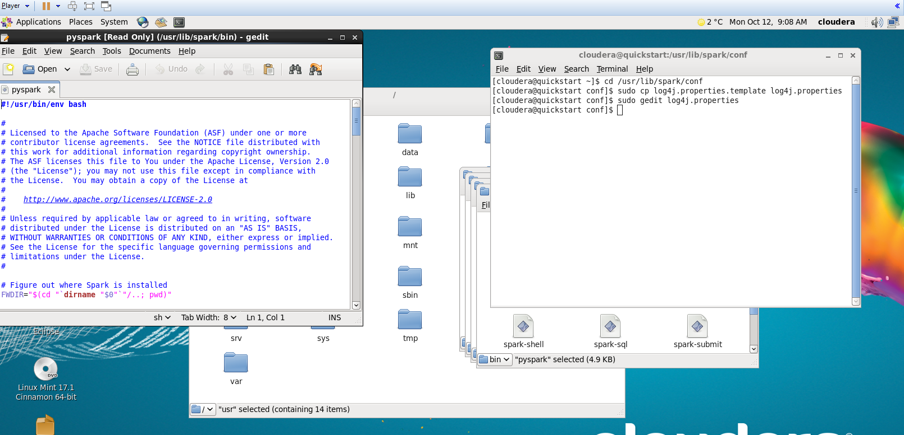
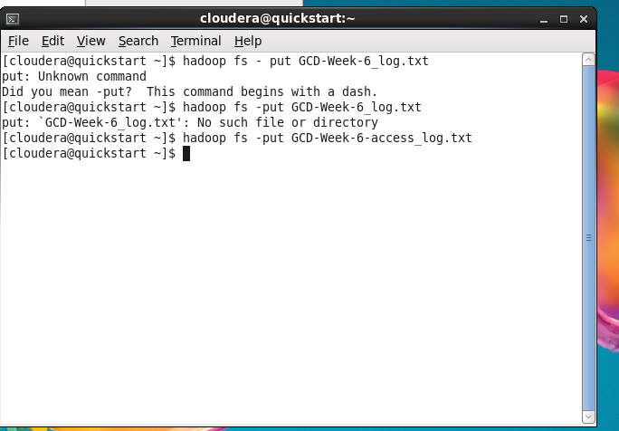
1: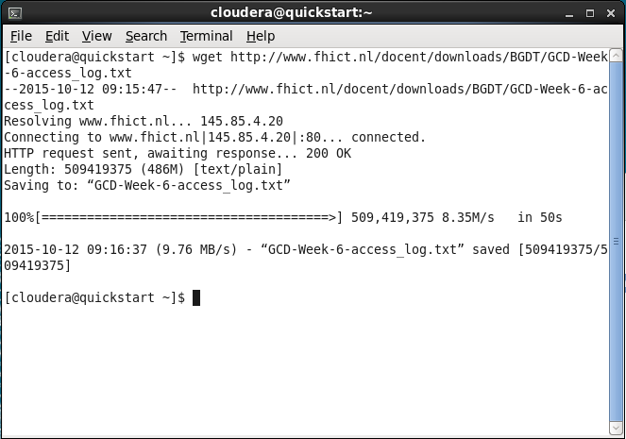

1.2: & 1.3:
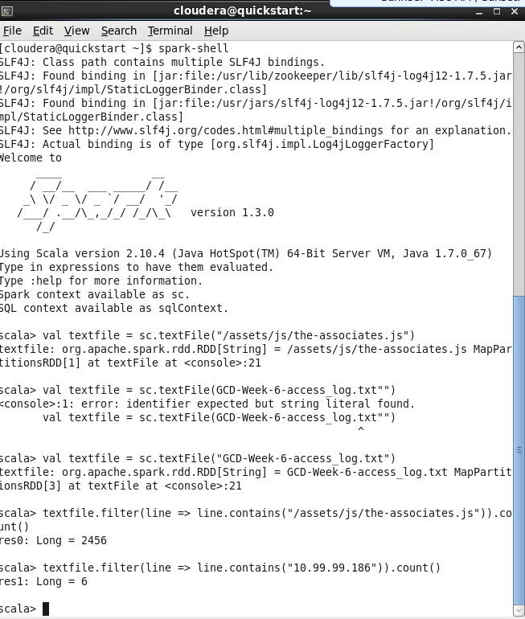
1.4: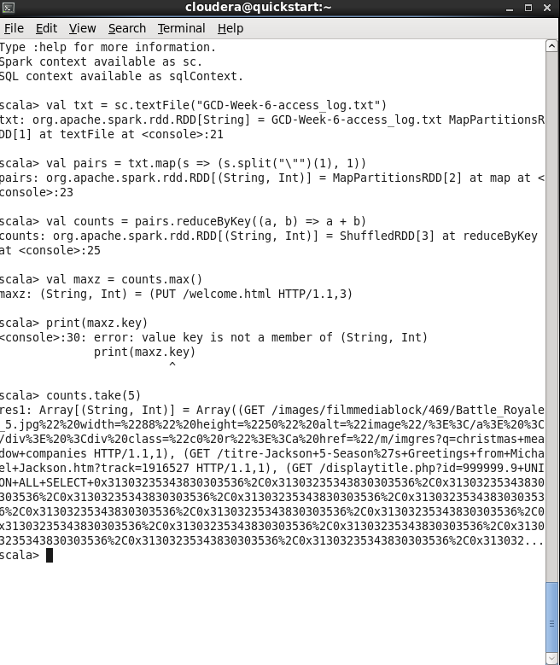
val txt = sc.textFile("GCD-Week-6-access_log.txt")
val pairs = txt.map(s => (s.split("\"")(1), 1))
val counts = pairs.reduceByKey((a, b) => a + b)
val maxz = counts.max()
val maxobj = counts.where(o => o == maxz)
print (maxz + " amount: " + maxobj

Activity 2.
Nadat Gutenberg op hdfs is gezet, doe ik vervolgens in scala:
p.s: heb perongelijk de terminal afgesloten voor ik een screenshot kon maken
Commando’s:
val textFile = sc.textFile("gutenberg-small/*.txt")
val counts = textFile.flatMap(line => line.split(" ")).map(word => (word.toLowerCase(), 1)).reduceByKey(_ + _).sortBy(_._2, false)
counts.take(10)
Resultaat:
Array[(String, Int)] = Array((the,48639), ("",38786), (of,24098), (and,21571), (to,18427), (a,17025), (i,12981), (in,10590), (was,9919), (that,9068))

Activity 3.
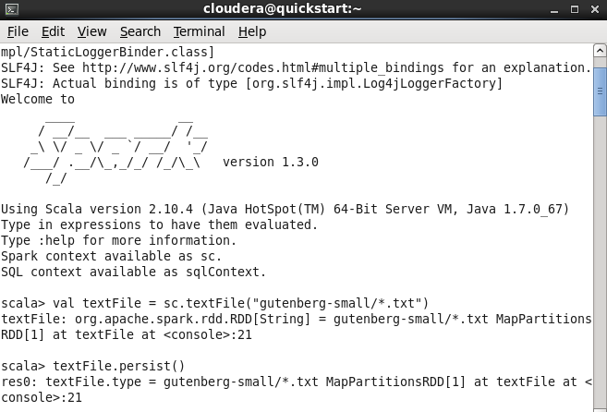

Week 7
Assignment 1:
Enter command: mongod --config /usr/local/etc/mongod.conf
3.checking the data, commands used in order:
mongo
show dbs
use scratch
show collections
db.zips.find()
4.Indexes:
Upon adding a index it will be used when querying the collection for a city.
5.Queries(only results noted)
- 29353
- 474
- [ "MA","RI",]
- ["AK","AL",]
- 51
- 356
- ["BUCKLAND","CAMBRIDGE","CLAYVILLE",...]
6. geo indexes
A.
db.zips.ensureIndex({"loc": "2d"})
db.zips.createIndex({"loc": "2dsphere"})

{
"createdCollectionAutomatically" : false,
"numIndexesBefore" : 2,
"numIndexesAfter" : 3,
"ok" : 1
}
B. longitude and latitude from: http://www.latlong.net/.
> db.zips.find({
loc: { $near: {
$geometry: { type: "Point", coordinates: [ -111.651302, 35.198284 ] },
$maxDistance: 5000
} }
})
Resulting in:
{ "_id" : "86001", "city" : "FLAGSTAFF", "loc" : [ -111.661979, 35.185911 ], "pop" : 30174, "state" : "AZ" }
Assignment 2: (case 3)
Tables:
User
- name

Post
- date
- text

Comment
- date
- text

Commenter
- name
Adding data:
db.users.save({
"name": "Stefan",
"posts": [{
"date": Date("2015-10-18"),
"text": "dit is saai",
comments: [{
"date": Date("2015-10-19"),
"text": "Paashaas",
"commenter": {
"name": "Harry"
}
}]
}]
})
db.users.save({
"name": "Henk",
"posts": [{
"date": Date("2015-10-10"),
"text": "Zijn we nu bijna klaar?",
comments: [{
"date": Date("2015-10-12"),
"text": "NEEEEEEE.",
"commenter": {
"name": "Gerard"
}
}]
}]
})

Eerste post vinden:
db.users.find({"posts.text": " dit is saai "})

